ФЕДЕРАЛЬНОЕ АГЕНТСТВО СВЯЗИ
Оренбургский филиал
федерального государственного бюджетного образовательного
учреждения высшего образования
«Поволжский государственный университет телекоммуникаций и информатики»

«УТВЕРЖДАЮ»
Директор ОФ ПГУТИ
Преснов А.А.
« » 2017г.

МЕТОДИЧЕСКАЯ РАЗРАБОТКА
для выполнения контрольных работ №1(1)
по учебной дисциплине
«Иностранный язык (английский)»

Обсуждено на заседании кафедры ГиСЭД
от « ___ » _________ 2017 г.
протокол № _____

Оренбург, 2017

Таблица выбора вариантов к контрольной работе №1 по дисциплине «Иностранный язык» - английский

Последняя  цифра  зачетной  книжки | 0 | 1 | 2 | 3 | 4 | 5 | 6 | 7 | 8 | 9
Номер  варианта | 1 | 2 | 3 | 4 | 5 | 1 | 2 | 3 | 4 | 5

МЕТОДИЧЕСКИЕ УКАЗАНИЯ
Все задания выполняются в письменном виде. Допустимы только общепринятые сокращения. Не принимается не отредактированный перевод.
Задания I по тексту контрольной работы выполняются, опираясь на содержание текста. Необходимо перевести письменно текст и задать 5 типов вопросительных предложений к тексту. Выписать и выучить 20 незнакомых слов из текста.
Задание II и III. Перед выполнением заданий необходимо повторить степени сравнения прилагательных.
Задание IV. Для выполнения задания повторите случаи употребления и образование Present Simple , Present Continuous.
Задание V. Для выполнения задания необходимо повторить случаи употребления и образование Present Perfect , Past Simple.
Задание V. Для выполнения задания необходимо повторить случаи употребления и образование Present Simple, Present Continuous, Present Perfect, Past Simple, Present Future.
Задание VII. Для выполнения задания повторите предлоги времени, направления, места.

Литература.
Основная литература

- Агабекян И.П. Английский язык для бакалавров/ И.П. Агабекян. – Изд. 2-е, стер. – Ростов н/Д: Феникс, 2012. – 379с.
- Агабекян И.П. Английский для инженеров / И.П. Агабекян, П.И. Коваленко. – Изд. 8-е, стер. – Ростов н/Д: Феникс, 2011. – 317с.

Дополнительная литература
- Бонк Н.А., Г.А. Котий и др. Учебник английского языка. В 2-х ч. Часть 1.- Переиздание. – М.: Деконт+ - ГИС, 2001. - 637 с.
- Бонк Н.А., Г.А. Котий и др. Учебник английского языка. В 2-х ч. Часть 1.- Переиздание. – М.: Деконт+ - ГИС, 2002. - 511 с.
- Андрианова Л.Н. Курс английского языка для вечерних и заочных технических вузов. – М.: высш. шк., 2008. – 463с.

Интернет-ресурсы
- https://www.ego4u.com/
- http://learnenglish.britishcouncil.org/en/
- http://www.perfect-english-grammar.com/
- http://list-english.ru/pdfschools/Teh.pdf

ВАРИАНТ 1
Переведите письменно текст. Выпишите 20 незнакомых слов и выучите их. Задайте 5 вопросов к тексту: общий, специальный, альтернативный, разделительный, вопрос к подлежащему.

Resume writing
What is a Resume?
A resume is a one page summery of your skills, education, and experience. The resume acts much like an advertisement for a company trying to sell something. The resume is your advertisement. Just as a company spends countless hours (and millions of dollars) designing their latest advertising campaign, you too must spend a good deal of time creating proofreading, editing, and perfecting your resume. A resume is one of the most important pieces of writing you will ever create. A solid resume is the key that will open the door to good jobs. Don’t cheat yourself … work hard on it.

How long do employers typically look at resume?
- Less that 30 seconds
- 8 mins
- 1 min
If you answered “A”, you are right. Employers often receive hundreds of resumes for a single position. They do not have time to read every word. This increases the importance of the smallest details.
What should be included in a resume?
Heading: Your heading should include the essential personal information. Your formal name (not nickname) should appear at the top. You want them to remember who you are in less than 30 seconds. Also include your address (both permanent and temporary) and phone number. If you use email, include your email address.
Objective (also called “Career Objective”): Employers often say this is the most important part of a resume. It is generally a one sentence explanation of the type of job you are seeking. Your objective should be fairy specific. If you are applying for different types of jobs, change your objective to match each type of job. If you are uncertain about the specific positions available, note your areas of interest.
Education: As students, this should be your next section of information. If you are in college, you only need to include college because it is assumed that you have graduated from high school. For the same reason, high school students shouldn’t include information from junior high/middle school. You should specify the dates of entrance or graduation (or expected graduation). As a college student, include the degree you expect to receive. Some people include education-related honors of this section. If your education is particularly relevant to a job, you may want to include a section titled “Relevant Courses.” In this category, you can list classes that might contribute to your employability.
Experience (also called “Work Experience” or “Employment Experience”): In this section, you should include previous employers, their locations, your dates of employment, and your job title. You should include at least two one-line descriptions of what your job duties and responsibilities were. You can not assume that the job title explains what you did to all readers. Use action verbs to start each of these descriptions. Do not use “I” in descriptions.

2. Образуйте степени сравнения прилагательных.
small; young; thin; thick; tall; beautiful; difficult; serious; comfortable; good; much; bad.
3. Перепишите предложения, раскрыв скобки.
February is (cold) than March.
John Williams is (young) than me.
Lake Baikal is (deep) than this lake.
Peter is (tall) than Boris.
Our flat is (more/less) comfortable than yours.
This dictation is (more/less) difficult than yesterday’s one.
This bird is (more/less) beautiful than ours.
Alex’s wrist-watch is (more/less) expensive than mine.

4. Переведите на английский язык, употребляя Present Indefinite и Present Continuous.
1. Я читаю газеты каждый день.
2. Сейчас я читаю журнал.
3. На каком иностранном языке говорит твоя сестра?
4. О чем они говорят?
5. Она хорошо играет на пианино.
6. Кто там играет на пианино?
7. Они не ходят в эту библиотеку.
8. Куда ты идешь? — Я иду в библиотеку.

5. Раскройте скобки, употребляя глаголы в Present Perfect или Past Simple.
1. At last I (to do) all my homework: now I shall go out.
2. The building of the house (to begin) early in April.
3. The rain (to stop) but a cold wind is still blowing.
4. We already (to solve) the problem.
5. He (to come) a moment ago.
6. I never (to speak) to him.
7. He just (to finish) his work.
8. You (to make) any spelling mistakes in your dictation?

6. Поставьте глаголы в скобках в правильную форму: Present Continuous, Present Simple, Present Perfect, Past Simple, Future Simple.
1. Most shops in Moscow (to close) ________________ at 6 p.m.
2. We ( to study) … at university in 2010.
3. At last I (to do) all my homework: now I shall go out.
4. The building of the house (to begin) early in April.
5. The teacher (to know) the girl often (not to argue) with pupils.
6. I (to think) she often (to worry).
7. Barbara’s boss (to see) she (to be) always late for work. .
8. I (to call) my son in Cedar Falls now.

7. Употребите нужный предлог-времени в предложении:

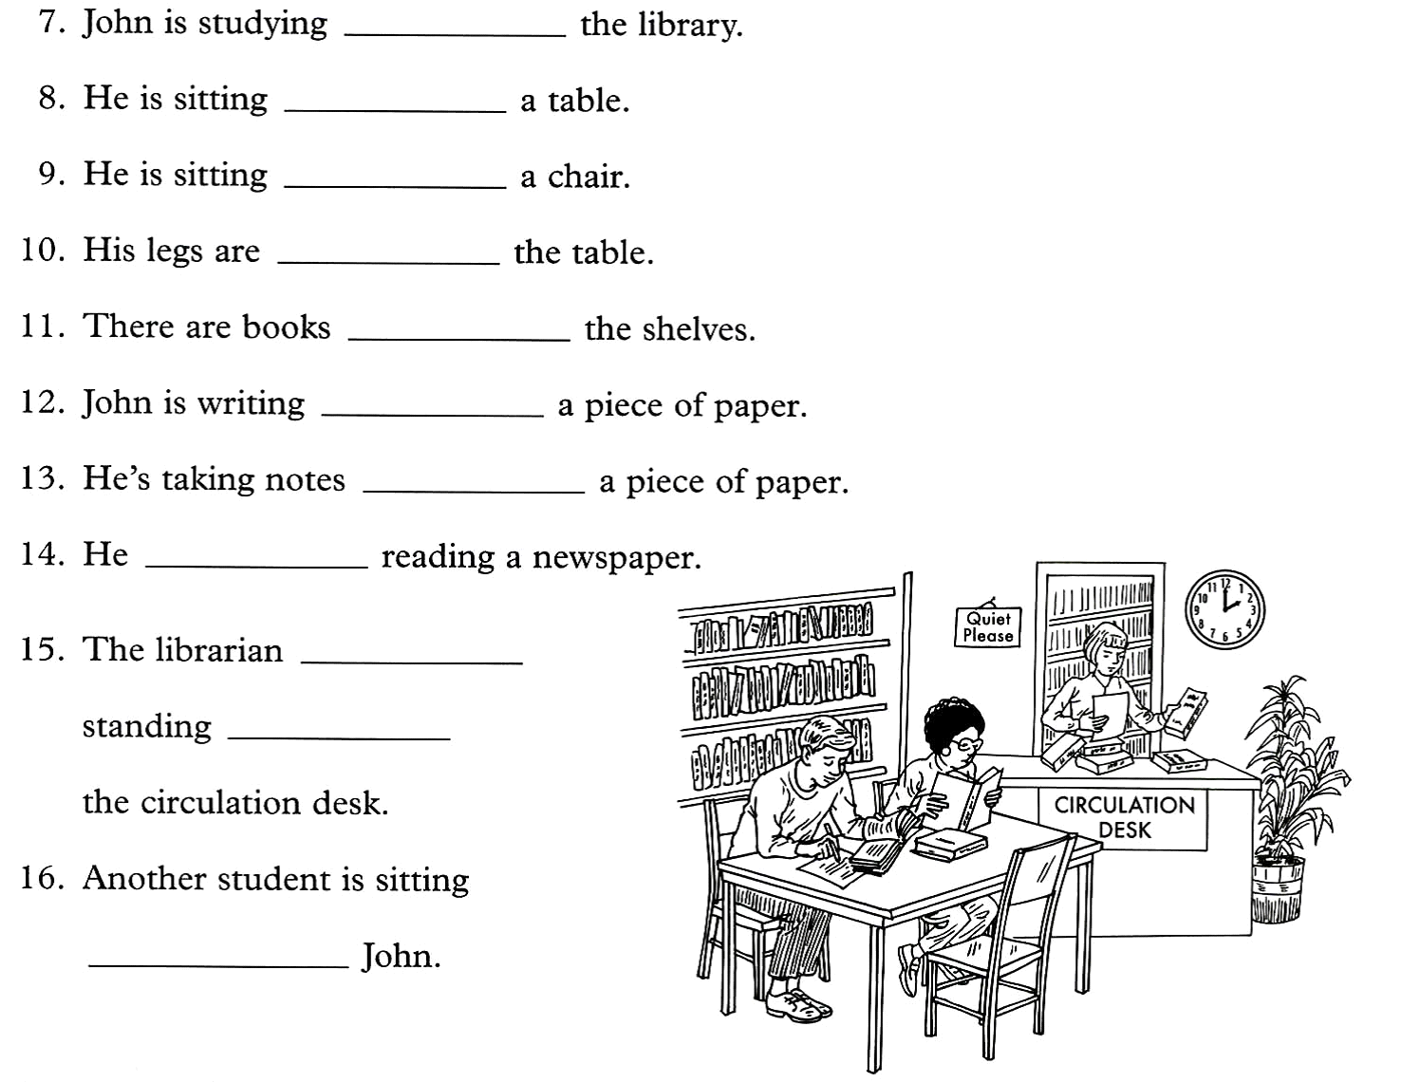

ВАРИАНТ 2

Переведите письменно текст. Выпишите 20 незнакомых слов и выучите их. Задайте 5 вопросов к тексту: общий, специальный, альтернативный, разделительный, вопрос к подлежащему.

Tips For Behaving In A New Office
You should be very attentive at work for the first day. It can be really dangerous if your take the first days in your office without much importance. It is a fact that a new employee will be observed at every second. Experienced people in the office will be interested in observing a new employee’s behavior and working style. There may be people who never like a new one in their cabin. You shouldn’t be a victim to their gossips by acting so silly.
When you are hired for doing a specific work, you have to take it as worship. Before you join an organization, you should ask yourself whether you want to do this job or not. If the job you got is your dream job, you should dedicate yourself completely in that to excel in the work. If you work hard, you can easily get a good name in your office.
Punctuality is a very good habit which is a must for an employee. Everybody likes punctual people. They will call you as ‘the man at the right time’. When the whole world is getting globalized and people do work for numerous clients, time is of course, money. When time is money, each and every minute you spend without a purpose is like wasting money. So reach your office in time or if possible before time. If you reach your office, say thirty minutes before time that will help you organizing the day’s work without any disturbance.
You must know your responsibilities. Don’t give a chance to the bullies to turn their machine guns on by being irresponsible. Try to achieve your work target every time, without fail. Check your finished work again and again for making it error-free. You should go through your office manuals and get a clear idea of what is expected from you.
When you are confused about any complexities in work, don’t waste your time by exclaiming and using some goofy logic. Seek help of the experienced people in your team. Your concern for the work will be expressed if you ask doubts. If you try to solve the problem on your own, it may take a lot of time and can be a reason for less productivity from your side.
Respect your company and take a pride in being the employee of the company. You should get to know the system of the company. If your company is running on a traditional system, do not pose as a revolutionary to change it all. Try to learn the advantages and disadvantages of that system and give suggestions for improvements at appropriate forums.

2. Образуйте степени сравнения прилагательных.

fine; new; straight; few; easy; busy; dirty; famous; expensive; suitable; charming; little; many

3. Перепишите предложения, раскрыв скобки.
1. Which is (large): the United States or Canada?
2. What is the name of the (big) port in the United States?
3. Moscow is the (large) city in Russia.
4. The London underground is the (old) in the world.
5. There is a (great) number of cars and busses in the streets of Moscow than in any other city of Russia.
6. St. Petersburg is one of the (beautiful) cities in the world.
7. The rivers in America are much (big) than those in England.
8. The island of Great Britain is (small) than Greenland.

4. Переведите на английский язык, употребляя Present Indefinite и Present Continuous.
1. Мой брат играет в теннис.
2. Они, наверное, играют в теннис.
3. Она не любит кофе с молоком.
4. Где живет твоя сестра?
5. Она смотрит телевизор каждый день.
6. Никто сейчас не смотрит телевизор.
7. О чем они говорят?
8. Она хорошо играет на пианино.

5. Раскройте скобки, употребляя глаголы в Present Perfect или Past Simple.
1. Why you (to put) these things in the wrong place?
2. Why you (to leave) the door open? You will catch cold sitting in the draught.
3. "We (not to meet) for such a long time!" said my friend. "Yes, indeed," I answered, "and we both (to grow)."
4. What books you (to read) when you (to live) in the country?
5. They (not yet to come) from the south.
6. He (to be) ill last week, but now he (to recover).
7. If everybody (to read) this new novel, let's discuss it.
8. You (to book) tickets? — Yes, I ... . I (to book) them several days ago.

6. Поставьте глаголы в скобках в правильную форму: Present Continuous, Present Simple, Present Perfect.
1. We (help) in the canteen this week.
2. I (never/work) in a restaurant before.
3. Martin usually (drive) to work.
4. But today, he (take) the bus.
5. We (already/plant) the apple tree.
6. Listen! She (practise) the piano.
7. My friend (play) the guitar every evening.
8. She (visit) India twice. I (not / meet) Francis tonight.

7. Употребите нужный предлог-времени в предложении:

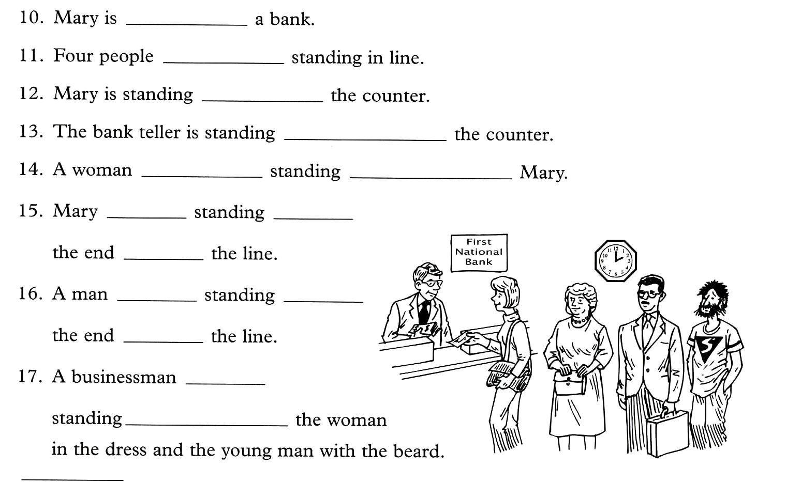

ВАРИАНТ 3

Переведите письменно текст. Выпишите 20 незнакомых слов из текста и выучите их. Задайте 5 вопросов к тексту: общий, специальный, альтернативный, разделительный, вопрос к подлежащему.

5 Famous Thinkers and Their Inspiring Daily Rituals
Many find it interesting to glimpse inside the lives of famous thinkers in an effort to understand where such thought and intelligence is rooted. In that vein, here is a peek into the routines and rituals that writers, philosophers, and statesmen have depended on to keep their work on track and their thoughts flowing. Whether you need inspiration to make it through the next college semester or are working on a future best-selling novel, explore these daily rituals you may want to incorporate into your life.
Fred Rogers. Don’t doubt that Fred Rogers was indeed a great thinker, despite the fact that he is best known as the familiar Mr. Rogers from the long-lasting PBS children’s show. His television show was a safe place for many young children, by his design, and he fought hard, in his quiet manner, for the show to stay on the air. The famous routine that started and ended his show was not the only routine in his life. Each day he would wake at 5:30 and begin his day with reading, writing, study, and prayer. He would take a swim most days of his life, take a late-afternoon nap, and go to bed at 9:30 each night. Perhaps the most idiosyncratic of his rituals was that he kept his weight at 143 pounds his entire adult life. He saw his weight one day and realized it aligned with the number of letters in "I love you" and vowed to maintain that weight, which he did.
Stephen King. This famed writer keeps to a strict routine each day, starting the morning with a cup of tea or water and his vitamin. King sits down to work between 8:00 and 8:30 in the same seat with his papers arranged on his desk in the same way. He claims that starting off with such consistency provides a signal to his mind in preparation for his work.
Immanuel Kant. Kant would begin his day with one or two cups of weak tea and a pipe of tobacco. While smoking, he would meditate. He would then prepare for his lectures, conduct lectures from 7:00 to 11:00, write, then have lunch. Lunch would be followed by a walk and time with his friend. The evening would consist of a bit more light work and reading.
Barack Obama. Taking care of physical fitness and family are two important elements of President Obama’s daily ritual. He starts his day with a workout at 6:45, reads several newspapers, has breakfast with his family, and then starts his work day just before 9:00 in the morning. He may work as late as 10:00 some evenings, but always stops to have dinner with his family each day.
Alexander Dumas. Whether or not he had heard the adage about keeping the doctor away, the writer of The Count of Monte Cristo and The Three Musketeers, Dumas started each day eating an apple under the Arc de Triomphe.

2. Образуйте степени сравнения прилагательных.
small; young; thin; thick; tall; beautiful; difficult; serious; comfortable; good; much; bad.

3. Раскройте скобки, употребляя требующуюся форму прилагательного.
1. Which is (large): the United States or Canada?
2. What is the name of the (big) port in the United States?
3. Moscow is the (large) city in Russia.
4. The London underground is the (old) in the world.
5. There is a (great) number of cars and busses in the streets of Moscow than in any other city of Russia.
6. St. Petersburg is one of the (beautiful) cities in the world.
7. The rivers in America are much (big) than those in England.
8. The island of Great Britain is (small) than Greenland.

4. Переведите на английский язык, употребляя Present Indefinite и Present Continuous.
1. Мы приближаемся к реке.
2. Дождь все еще идет.
3. Почему они так смотрят на нас.
4. Он говорит слишком быстро, и я плохо понимаю его.
5. Что вы хотите послушать?
6. Я никогда не принимаю ванну по утрам.
7. Он всегда ждет здесь свою сестру после работы.
8. Сколько часов в день вы работаете?

5. Раскройте скобки, употребляя глаголы в Present Perfect или Past Simple..
We (not / have) a holiday last year.
My parents (be) to the USA many times.
I (buy) a new dress last week, but I (not / wear) it yet.
… it (stop) raining yet?
Don’t worry about your letter. I (send) it the day before yesterday.
I (lose) my glasses. I (have) them when I came to college in the morning.
When Jill (finish) school?
When I was a child, I (always / be) late for school.

6. Поставьте глаголы в скобках в правильную форму: Present Continuous, Present Simple, Present Perfect.

Maria (want) to improve her English. Therefore, she (do) a language course in London at the moment. She (stay) with a host family and (must) take the tube to get to her language school.
My parents (since/help) me a lot I lost my job.
It (be) only a five-minute walk to the nearest tube station. The tube (leave) at half past eight. The first lesson (begin) at 9 o'clock. In the afternoons, the school (offer) sightseeing tours in and around London. Tomorrow, the students of the language school (go) to Windsor.

7. Употребите нужный предлог в предложении:
1 There are a lot of parties …. the New Year Eve.
2 Henry is 63. He’ll be retiring …. his job …. two years time.
3 All the players shook hands …. the end of the match.
4 There’s nobody living …. the island. It’s uninhabited.
5 It’s a very small village. You probably won’t find it …. the map.
6 There were fifty rooms …. the hotel.
7 Have you ever been …. China?
8 In Britain, children start school …. the age …. five

ВАРИАНТ 4

Переведите письменно текст. Выпишите 20 незнакомых слов из текста и выучите их. Задайте 5 вопросов к тексту: общий, специальный, альтернативный, разделительный, вопрос к подлежащему.

5 Famous Thinkers and Their Inspiring Daily Rituals

Many find it interesting to glimpse inside the lives of famous thinkers in an effort to understand where such thought and intelligence is rooted. In that vein, here is a peek into the routines and rituals that writers, philosophers, and statesmen have depended on to keep their work on track and their thoughts flowing. Whether you need inspiration to make it through the next college semester or are working on a future best-selling novel, explore these daily rituals you may want to incorporate into your life.
1. Haruki Murakami. This popular Japanese novelist sticks to a specific daily schedule that begins at 4:00 when he awakes. He writes for five or six hours, then either runs 10k or swims 1500 meters (or sometimes, both). After his workout, he reads and listens to music until he goes to bed at 9:00. Murakami claims that writing a novel requires both the physical and mental strength that his routine provides.
2. Charles Darwin. In his middle and later years, Darwin stuck to a very rigid schedule that started at 7:00 in the morning with a short walk, then breakfast. He would then work throughout the morning. Lunch, at 12:45, was his biggest meal of the day. His afternoon was also scheduled and consisted of two walks, reading, and backgammon. Darwin could not tolerate much socializing, and kept it to a maximum of 30 minutes at a time.
3. Winston Churchill. While Churchill’s routine may not be for everyone, it seemed to revolve around lots of food and drink. He would rise at 7:30 and stay in bed until 11:00 where he would eat breakfast, read several newspapers, and dictate to his secretaries. When he finally got out of bed, he would bathe, take a walk outside, then settle in to work with a weak whisky and soda. Lunch began at 1:00 and lasted until 3:30, after which he would work or play cards or backgammon with his wife. At 5:00 he napped for an hour and a half, then bathed again and got ready for dinner. Dinner was considered the highlight of his day, with much socializing, drinking, and smoking that sometimes went past midnight. After his guests left, he would then work for another hour or so before heading to bed.
4. Aldous Huxley. This famous thinker and writer would start early each day sharing a breakfast with his wife. He would work uninterrupted until lunchtime. After lunch, he and his wife would go for a drive or a walk, then he would return to work again from 5:00 to 7:00, then have dinner. After dinner, his wife would read to him until almost midnight. Due to an eye illness early in life that left Huxley with very poor eyesight, he relied heavily on his wife to do many activities for him besides reading. She often typed his manuscripts and was even reported to have cut his steak for him at dinner.
5. James Thurber. Another writer with difficulties seeing, Thurber would often compose his work in his head at almost anyplace he found himself. His wife would recognize the look in his eyes and interrupt him mid-paragraph while they were socializing at a party, and his daughter saw him retreat into his private world over dinner. His method later in life was to spend all morning composing his text in his head, then between 2:00 and 5:00 he would dictate about 2,000 words to his secretary.

2. Образуйте степени сравнения прилагательных.

fine; new; straight; few; easy; busy; dirty; famous; expensive; suitable; charming; little; many

3. Раскройте скобки, употребляя требующуюся форму прилагательного.
I met my (good) friend yesterday.
Dorothy is (young) in her family.
Henry is not (strong) his elder brother Bob..
– It isn’t very warm today, is it?
No, it’s (warm) than yesterday.
Your friend looked upset yesterday. I’m glad he looks (happy) today.
Where is (near) post-office, please?
This is (old) theatre in London.
My (old) sister doesn’t live with us.

4. Переведите на английский язык, употребляя Present Indefinite и Present Continuous.
1. Почему они так смотрят на нас.
2. Он говорит слишком быстро, и я плохо понимаю его.
3. Что вы хотите послушать?
4. Я никогда не принимаю ванну по утрам.
5. Он всегда ждет здесь свою сестру после работы.
6. Сколько часов в день вы работаете?
7. Почему они здесь ходят?
8. Семестр начинается первого сентября.

5. Раскройте скобки, употребляя глаголы в Present Perfect или Past Simple..
1. It (to be) very cold yesterday.
2. When you (to meet) him?
3. I (not to see) him. since 1998.
4. How many mushrooms you (to gather)?
5. Where you (to put) the newspaper? I want to read it, but cannot find it anywhere.
6. The new school (to begin) working last year.
7. You (to read) all the books on this shelf?
8. I (not to see) my cousin since last year.

6. Поставьте глаголы в скобках в правильную форму: Present Continuous, Present Simple, Present Perfect, Past Simple.

1. You (to read) this book? – I (to read) it now, I (not finish) it yet. It (to be) a very good book, I (to like) it very much.
2. We (to go) to the café tonight. You ever (to be) there?
3. Where (to be) Ann? – She (to be) in the kitchen. – What she (to do) there? – She (to wash up). – I already (to help) my mother and (to come) to ask Ann to go to the cinema with me.
4. When she (to call) on us she always (to bring) some toys for my little daughter.
5. What you (to look for)? – I (to look for) my dictionary. – I just (to see) it somewhere. I (to think) it (to lie) on the bookshelf.
6. I (not to hear) the news yet.
7. Yesterday he (to wash) … his face at a quarter past seven.
8. I ( to work) … at the office 3 years ago.

7. Употребите нужный предлог в предложении:
1 The advantage ….having a car is that you don’t have to rely …. public transport.
2 I don’t mind going …. Car but I don’t want to go …. your car.
3 When I was 14, I went …. trip …. France organized …. my school.
4 What time does the train arrive …. London?
5 The exhibition …. the Museum of Modern Art finished ….Saturday.
6 When I am a passenger …. a car, I prefer to sit …. the front.
7 The leaves …. that tree are …. beautiful colour.
8 I am going away …. the end of month.

ВАРИАНТ 5

Переведите письменно текст. Выпишите 20 незнакомых слов из текста и выучите их. Задайте 5 вопросов к тексту: общий, специальный, альтернативный, разделительный, вопрос к подлежащему.

Business trips
This is Mr. Voronin. He is a successful Russian businessman. He has been in business for about 10 years. He often goes to different countries to do business with foreign companies. Now Voronin is in London. He works at the Russian Trade Delegation.
Voronin is usually very busy. He has got much work to do every day. His office hours begin at 8:30. In the morning he looks through Russian and English newspapers and journals. He is interested in the political and business events.
During the day Voronin meets English businessmen and discusses with them prices for different goods, terms of payment, shipment and delivery. Sometimes he discusses business matters on the phone. Together with Russian businessmen he often goes to plants and outside London.
Now he is in his office in Highgate. It’s 2 o’clock in the afternoon. He is looking through the mail. He usually receives much mail but today he has got few letters and telexes on his desk. He is reading a letter. It is an enquiry for chemical equipment from his company. Voronin knows “Blake and Co” are selling model of this equipment.
Now Voronin is making an appointment on the phone with Mr. Blake, the manager of the company.
Secretary: Blake and Co. Good morning!
Voronin: Good morning! This is Voronin of the Russian Trade Delegation. I’d like to speak to Mr. Blake.
Secretary: Just a moment, please.
Blake: Blake speaking.
Voronin: Good morning, Mr. Blake. I’ve got an inquiry for chemical equipment from my company. We are interested in your new model. I’d like to have your latest catalogues and quotation. Could I meet you at our Trade Delegation on Monday.
Blake: Oh, I’m very busy on Monday. How about Wednesday morning at 10 o’clock.
Voronin: Good. See you on Wednesday. Good bye!

2. Образуйте степени сравнения прилагательных.
small; young; thin; thick; tall; beautiful; difficult; serious; comfortable; good; much; bad.

3. Перепишите предложения, раскрыв скобки.
1. February is (cold) than March.
2. John Williams is (young) than me.
3. Lake Baikal is (deep) than this lake.
4. Peter is (tall) than Boris.
5. Our flat is (more/less) comfortable than yours.
6. This dictation is (more/less) difficult than yesterday’s one.
7. This bird is (more/less) beautiful than ours.
8. Alex’s wrist-watch is (more/less) expensive than mine.

4. Переведите на английский язык, употребляя Present Indefinite и Present Continuous.
1. Я читаю газеты каждый день.
2. Сейчас я читаю журнал.
3. На каком иностранном языке говорит твоя сестра?
4. О чем они говорят?
5. Она хорошо играет на пианино.
6. Кто там играет на пианино?
7. Они не ходят в эту библиотеку.
8. Куда ты идешь? — Я иду в библиотеку.

5. Раскройте скобки, употребляя глаголы в Present Perfect или Past Simple.
1. I (meet) two of my friends today. I (meet) them on my way to school.
2. A month ago my uncle (build) a new house in the country. We (visit) it recently and (enjoy) ourselves very much.
3. He (forget) to close the window when he (leave) the house.
4. He (write) several letters this week.
5. Where Helen (go)? I don't see her here. — She (go) home an hour ago.
6. When the concert (to begin)?
7. I don't think I ever (to see) such a beautiful garden as this one.
8. Jack London (to be born) in San Fransisco in an extremely poor family.

6. Поставьте глаголы в скобках в правильную форму: Present Continuous, Present Simple, Present Perfect, Past Simple.
1. He (sleep) since nine o’clock. It’s time to wake him up.
2. I (lose) my key. I (try) to wake my mom by throwing stones at her window.
3. He (teach) in this school for five years.
4. This (be) Mr Smith.
5. He (be) a dentist.
6. He (work) in this hospital for 10 years.
7. It (be) 7 p.m. and he just (come) home.
8. What he (do) now? He (cook) dinner for his wife. It (be) her birthday.

7. Употребите нужный предлог в предложении:
1 Mozart was born in Salzburg …..1756.
2 I haven’t seen Kate for a few days. I saw her ….. Tuesday.
3 I’m going ….. the end of the month.
4 I like that picture hanging ….. the wall …..kitchen.
5 It can be dangerous when children play ….. the street.
6 Shall we travel ….. your car or mine?
7 She saw you, stopped and offered you a lift. She opened the door. What did you do? I got ….. car.
8 Water boils …..100 degrees Celsius.

